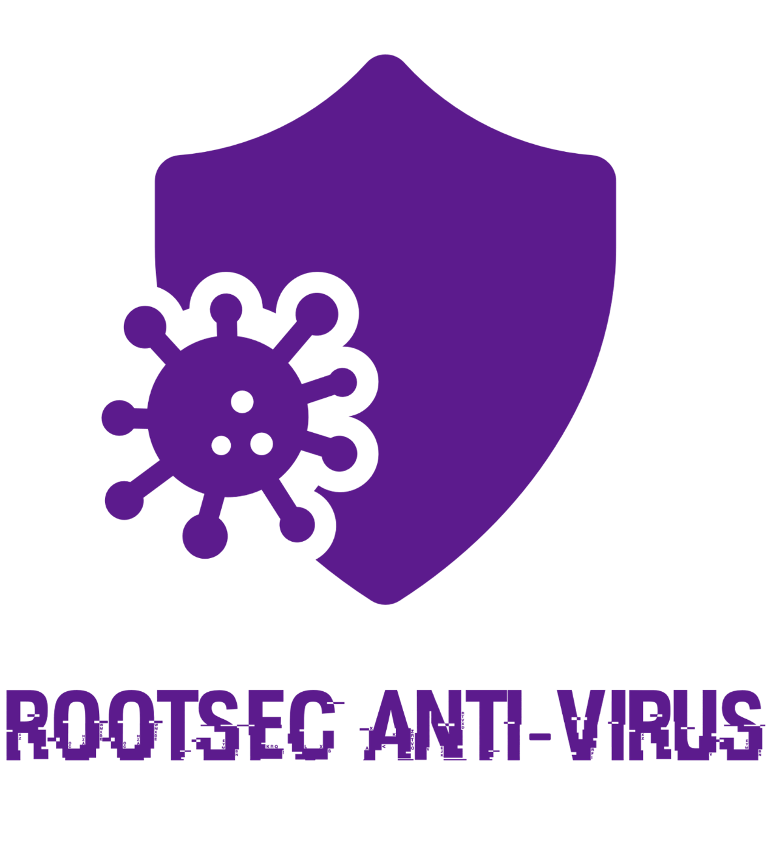



**IT20249984 – Hewage G H D T**

**IT20224448 – Jayarathna L D C**

**Introduction**

This application has one of the most essential functions, which is the ability to upload encrypted local files to a web server. AESD stands for Advanced Encryption Standard (AES). Numerous features of the software make it a proactive, multipurpose workhorse. For those attempting to upload their private files to the cloud, this program is really beneficial. It simply involves employing the Advanced Encryption Algorithm (AES) to encrypt the file before sending it over the internet to the cloud. The app client also has a decrypting feature for users who want to decrypt files correctly.

Functions

**FACE RECOGNITION LOGIN FEATURE**

It could be difficult to identify faces in an image. Designers can obtain frameworks that are both open source & proprietary to make finding faces simpler. Neurotechnology VeryLook is a commercially available library that I can suggest. The most well-known Open-Source face recognition framework is probably Intel's OpenCV (Open Computer Vision), which can do a lot more than just identify faces. It is difficult to use in the.NET environment because it is dependent on the C++ programming language. EmguCV offers a.NET interface to OpenCV routines to address this problem. Despite their strength, these frameworks are not particularly user-friendly.

Using the Open-Source package Accord.net, which was created on basis of the AForge imaging library I discussed in this report about using web cameras with VB.NET, We would describe in this research the easiest method of detecting faces.

When creating solutions for biometric enrolment systems, We deploy face detection. According to global standards, identifying a face is a crucial stage in creating the right facial image (ICAO). Government documents like biometric passports, visas, and national IDs can only use standardized photos.

**AES-BASED FILE ENCRYPTION AND DECRYPTION**

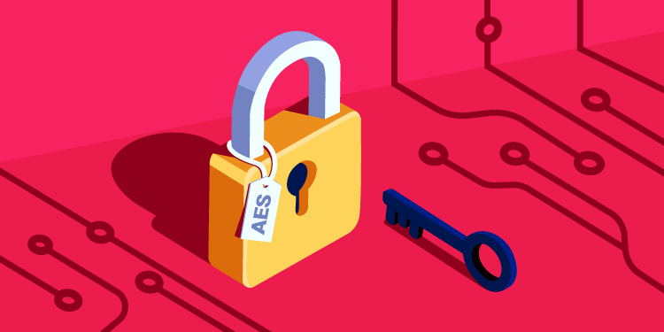

AES algorithm, often known as the advanced encryption standard, seems to be a cipher that safeguards data transmission over the internet.

AES is now one of the greatest data encryptions that is readily available since it perfectly balances speed and security, allowing us to go about our regular internet activities even without hindrance.

It is not surprising that AES became the mainstream technology for encryption given its benefits.

You will learn about the history of AES, its applications, and any security risks in this post. Additionally, you will understand how AES encryption functions by going through each encryption round step-by-step.

Algorithm is a symmetric encryption method since it employs the same key for both both encryption and decryption.

Additionally, it employs numerous rounds of the SPN (substitution permutation network) method to encrypt data. An impenetrability of AES is a result of these encryption rounds, which are impossible to break through due to their sheer number.

AES encryption keys come in three-bit sizes. The number of key combinations is variable for each key length:

**Key length of 128 bits: 3.4 x 1038**

**Key length of 192 bits: 6.2 x 1057**

**Key length in 256 bits: 1.1 x 1077**

This encryption technique has a variable key length, but a fixed block size of 128 bits (or 16 bytes).

There are various issues with the range of key lengths. Why do keys come in different lengths? Why don't we just use the 256-bit key all the time if it's the strongest among them (it's even referred to as "military-grade" encryption)?

Well, resources are what ultimately matter. For instance, an app that employs AES-256 rather than AES-128 can cause your phone's battery to discharge a bit more quickly.

Thankfully, modern technology reduces the resource difference to such a negligible level that there is absolutely no justification for not using 256-bit Encryption.

* *Advantages of AES*

AES encryption is immensely enticing to those who engage with it, safety concerns aside. Why? because AES's encryption method is rather simple to comprehend. This enables quick encryption and decryption speeds, as well as simple implementation.

AES is a clear victor when it comes to selecting your chosen encryption method because it also uses fewer memory than most types of encryptions (such as DES).

Finally, you can connect AES with different security procedures like WPA2 and perhaps other forms of encryption like SSL when an action demands an additional layer of security.

* Why do we use the AES algorithm?

The advanced encryption standard is old, if not quite "ancient."

AES has been operating for more than 20 years and was first created in 1998 by two Belgian cryptographers, Vincent Rijmen and Joan Daemen. Its first name, Rijndael, was a combination of the names of its creators.

AES encryption has already been the industry standard for 18 years due to its impenetrability. This is as a result of the National Institute of Standards and Technology (NIST) switching to AES in 2002 from the obsolete Data Encryption Standard (DES).

* What applications uses the AES algorithm?

AES encryption had humble origins as the preferred cipher of the US government, but it swiftly swept the globe and became the encryption standard for pretty much everything we see online. You will therefore have a difficult time locating businesses or services that don't make use of the AES algorithm.

Messages, passwords, and login information for online banking all need to be secured from malicious parties. Thus, the advanced encryption standard not only "serves" the government (such as the National Security Agency), but also safeguards the private information of several products.

* How is AES encryption carried out?

What you need realize right away is that the AES encryption method might be difficult to comprehend without the necessary background information. You would likely need to major in mathematics to properly understand its nuances (at least).

Fortunately, the AES cipher's internal operations can be made simpler. One method is to substitute "regular" symbols for the binary code.

I'll give a brief explanation of the primary concept underlying AES's cryptography in the parts that follow.

1. Dividing data into blocks

We must first remember that AES is a block cipher. It encrypts data in blocks of bits instead of bits at a time, unlike stream ciphers.

Each of its blocks has a four-by-four layout with a column of 16 bytes. Eight bits make up one byte, therefore we get a block size of 128 bits (16x8=128).

Thus, slicing plaintext—text that is not written in code—into these blocks constitutes the first phase in the AES encryption process.

Decide on the text you wish to encrypt now. It may be "better late than never," for instance.

The first part of this sentence would become the following block if the advanced encryption standard were to be used:

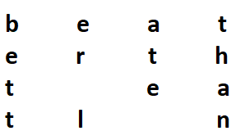

1. Key expansion

This is a crucial stage in the AES encryption process. It generates fresh 128-bit round keys using Rijndael's key schedule.

Suppose "extraterrestrial" is our first key:

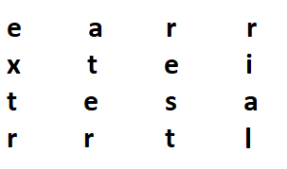

The phrase will appear as a tangle of random characters after applying Rijndael's key schedule, and could resemble something like this:

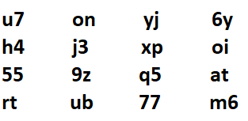

However, since Rijndael's key schedule employs particular procedures to encrypt each and every symbol, these characters won't be entirely random after all.

This new set of extended keys will be required later by the AES algorithm.

1. Adding round key

This cycle of AES encryption is the first ever. Here, the algorithm expands our phrase, which was earlier transformed into a 4x4 block, by adding the first key:

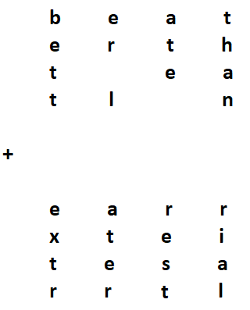

I am aware that it can seem impossible to add two blocks of text. But keep in mind that AES actually operates in binary code; what you are currently viewing is merely a visual depiction of what is occurring in the binary language.

We thus obtain an entirely new block of cipher after combining the two blocks, which I shall represent as follows:

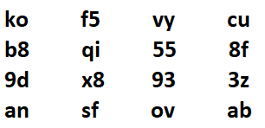

1. Byte substitution

Now, the Rijndael S-box is a pre-established table that the AES algorithm uses to replace each byte with a code. It appears as follows:

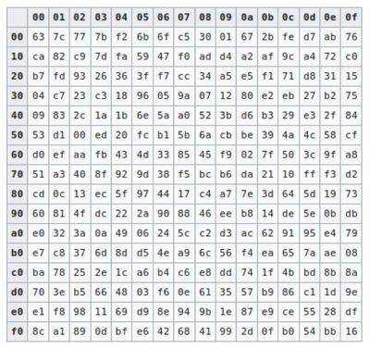

The table states that a number like 19 becomes d4, e9 becomes 1a, and so forth. Therefore, after the byte substitution procedure, my block of cipher would look like this (bearing in mind that this is still just a hypothetical depiction of what the actual thing looks like):

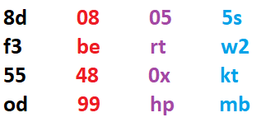

As you can see, I used various colors to mark a few columns. The next action will require this.

1. Shifting rows

The AES algorithm moves the lines of the block it obtained via the byte substitution operation in this phase.

The front row doesn't move. Nevertheless, the second row is moved one byte to the left, the third row is moved two bytes to the left, and the last row is moved three bytes to the left:

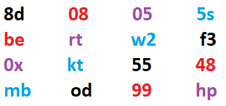

1. mixing columns

In terms of math, this phase multiplied each column by a predetermined matrix to produce a fresh block of code.

It is a really difficult process that requires a lot of sophisticated mathematics.

Let's assume for sake of simplicity that I conducted the calculations and that my new block now like this:

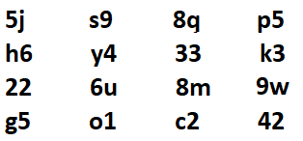

1. Adding round key

Applying the round key from the key expansion part is now necessary. After the column mixing procedure, let's add it to the block we obtained in the preceding section:

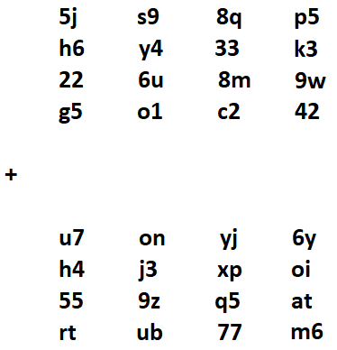

This results in the creation of yet another block of binary code, which later goes through numerous further alterations.

1. Rinse and repeat

The AES encryption process will now go through numerous additional rounds of byte substitution, row and column shifting, and the addition of a round key.

The AES key length determines how many identical rounds are performed on the data:

**9 rounds for a 128-bit key**

**11 cycles for a 192-bit key**

**13 cycles for a 256-bit key**

Thus, the data repeats the aforementioned procedures 13 times in the case of 256-bit key encryption, for instance.

The data will therefore have gone through the specified number of rounds at the very conclusion of the encryption process:

**10 rounds with a 128-bit key**

**12 cycles for a 192-bit key**

**14 cycles for a 256-bit key**

The original phrase "better late than never" will appear as a collection of random characters once all rounds have been finished.

***AES decryption***

The AES encrypted message can be returned to its original state using inverse encryption.

As was already noted, symmetric cryptography is used in the advanced encryption standard. In other words, both data encryption and decryption use the same key.

This distinguishes it from asymmetric encryption techniques, which demand both public and private keys.

The inverted round key is used to start the AES decryption process in our scenario. The algorithm then reverses each and every step (shift rows, byte replacement, and later column mixing), until it is able to decrypt the original message.

**File Encryption and Decryption Tool**

**Algorithm we used**

So far, various algorithms have been used to encrypt various file formats such as text files, audio files, images, and videos. While there are numerous encryption algorithms. RSA (Rivest, Shamir, Adleman) and DES are two encryption algorithms (Data Encryption Standards). The DSA (Digital Signature Algorithm) is used in this tutorial to encrypt and decrypt text files because it is more efficient in terms of time and security. This results in more refined encryption than is currently available.

We use the DSA algorithm to encrypt the text file. To begin, we take the ASCII value of each character in the text file and place it in the appropriate size grid. Data from the grid is read diagonally and written row by row from left to right in a new grid of equal size. The sender encrypts the text file with the private key, and the file is decrypted with the sender's public key at the receiving end, ensuring authentication, integrity, and confidentiality.

**Use of the tool**

Data encryption protects the confidentiality of your email messages, documents, and sensitive files. Encryption can be used on both text data and files. We must choose what to encrypt, and encryption and decryption aid in the confidentiality of documents, personal information, and files. Encryption is also used to ensure the confidentiality of the adversary's files and documents so that they remain secure.

Data encryption is also used to protect and secure files and other important documents from adversaries, ensuring that no one other than the recipient can see the files or documents while they are being sent.

The project uses a similar mechanism to provide file security and safety by employing a public key algorithm known as DSA.

**Code**

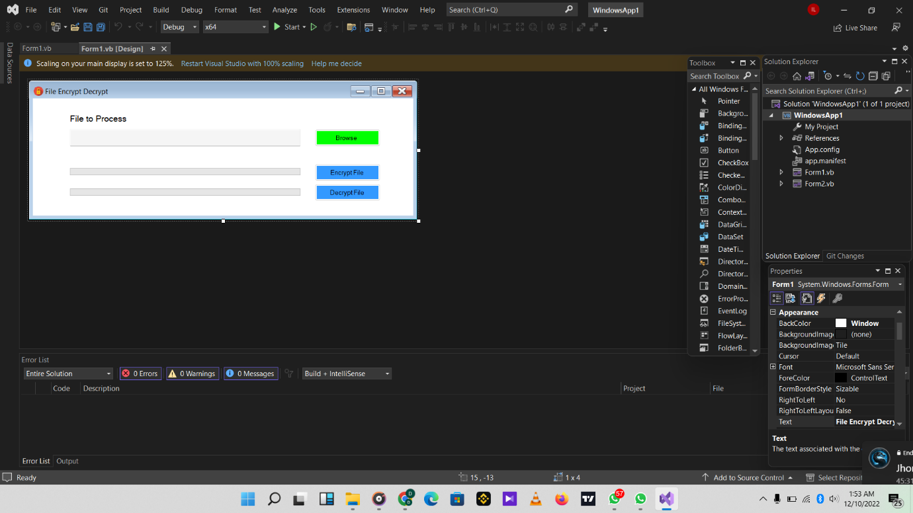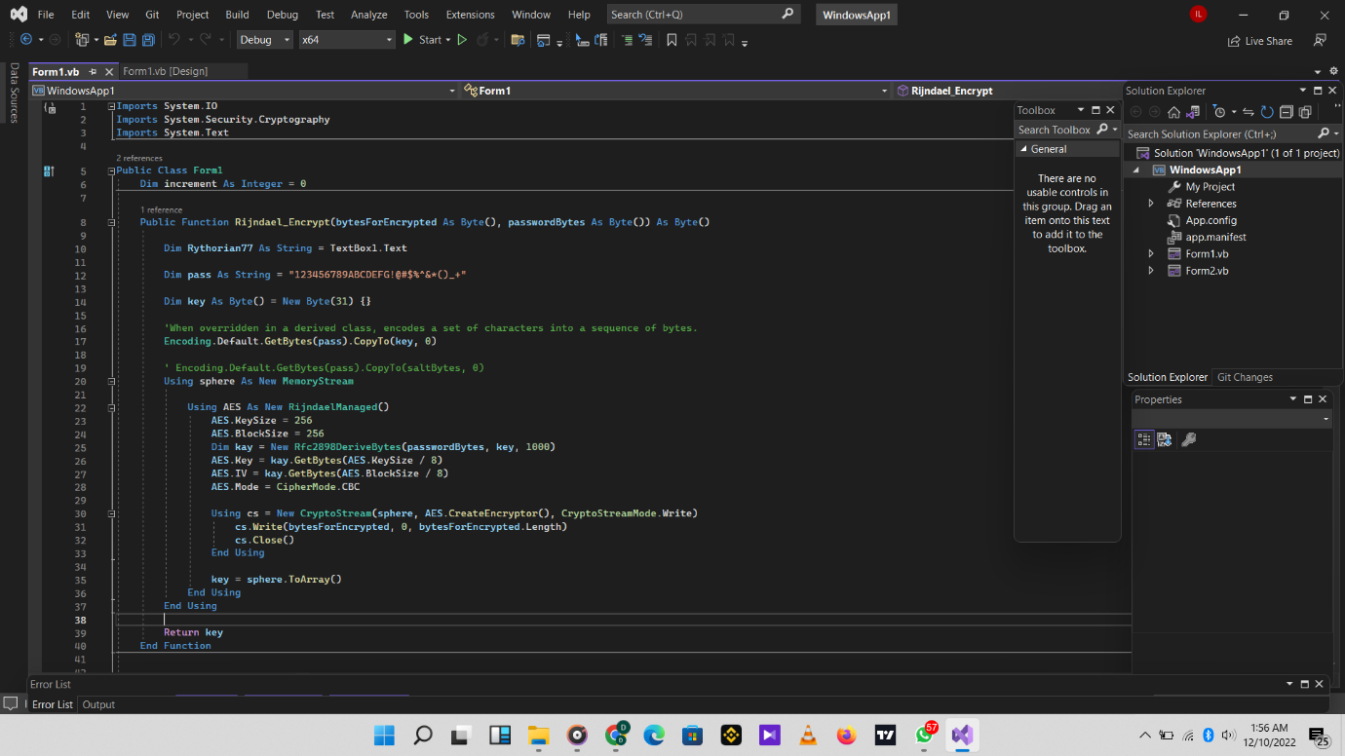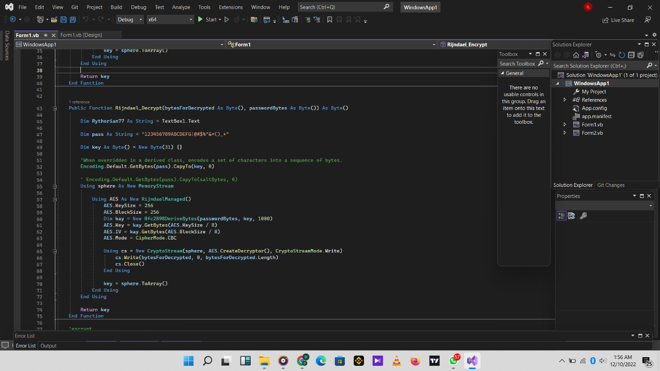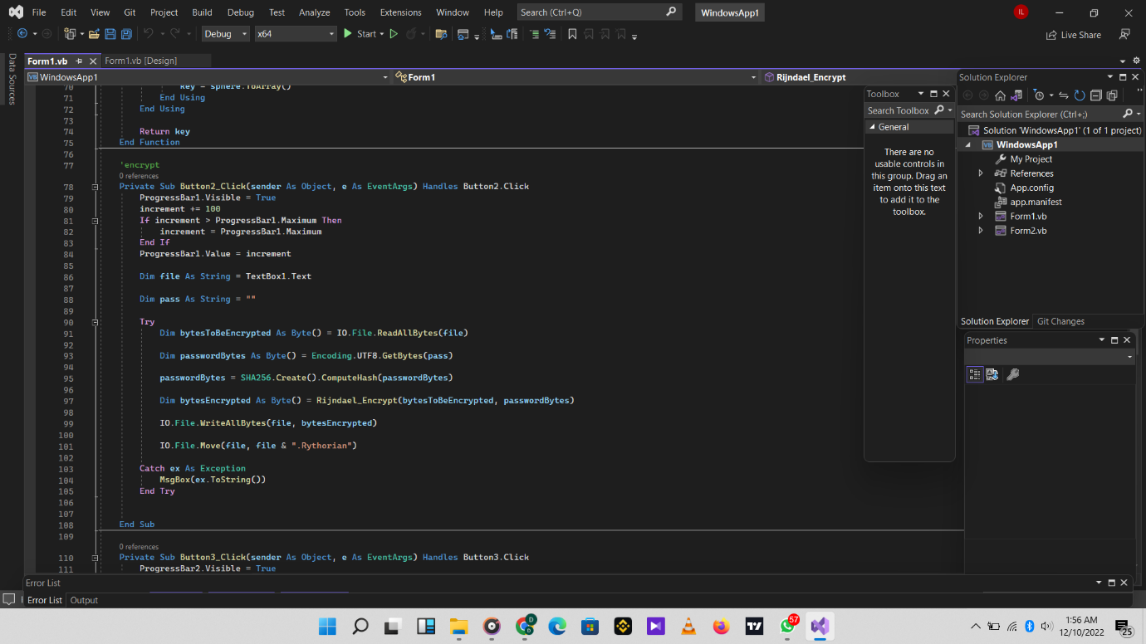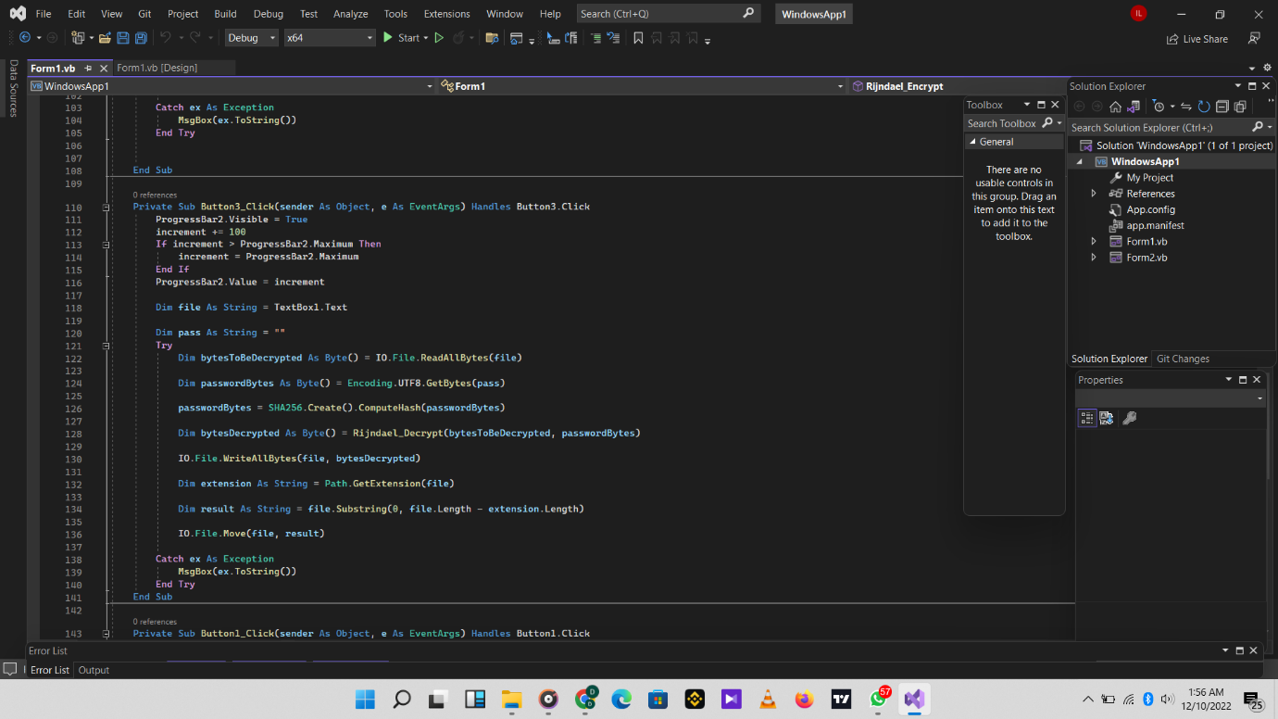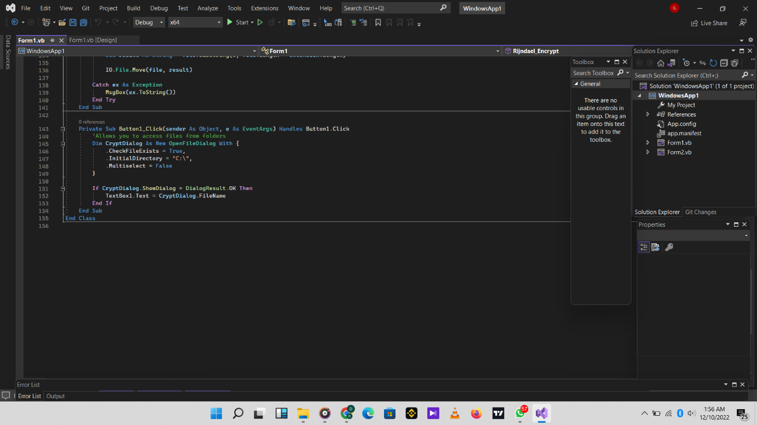

**Tool Launching**

This is the interface of the file encrypt decrypt tool.

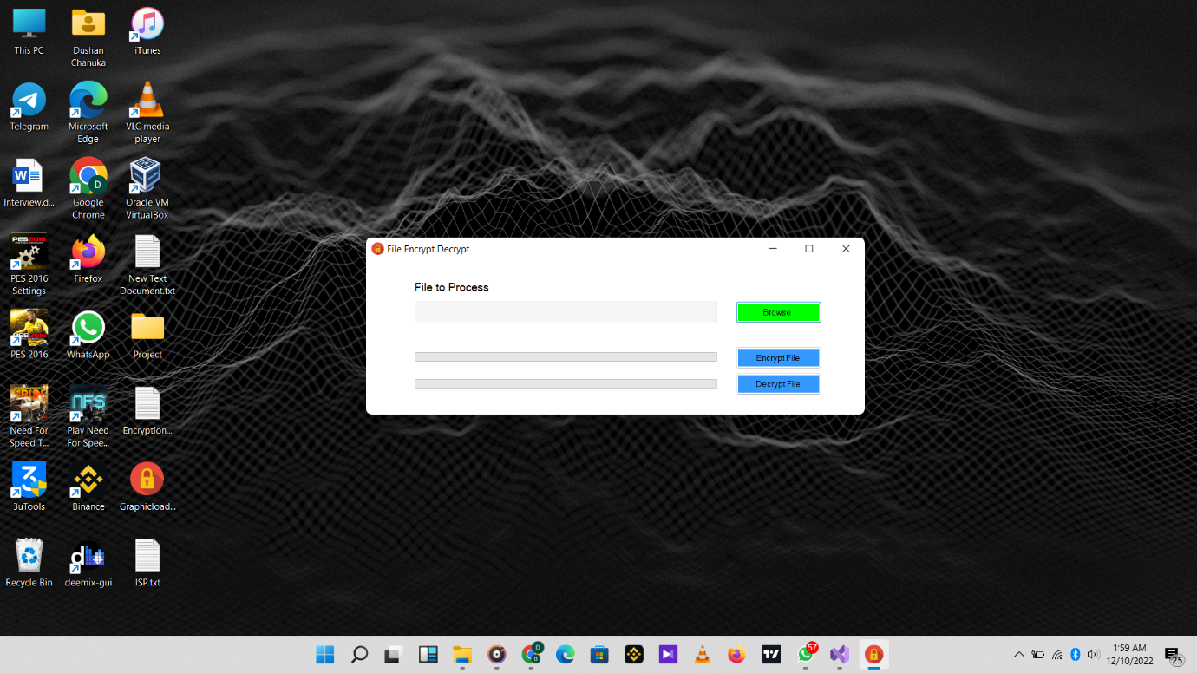

First, we have to browse the file that we want to encrypt. According to this tool we can encrypt any kind of a file. Such as word file PowerPoint project, text files and also we can encrypt any kind of images like png, jpeg, etc. Click the browse button to browse.

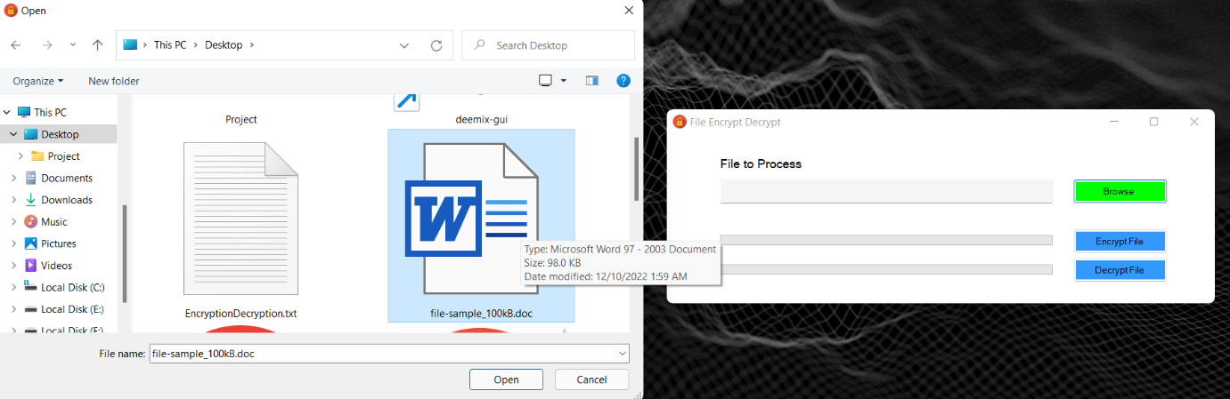

In here we choose a sample word document to encrypt. After we hit the browse button, that files directory is shown in the text bar.

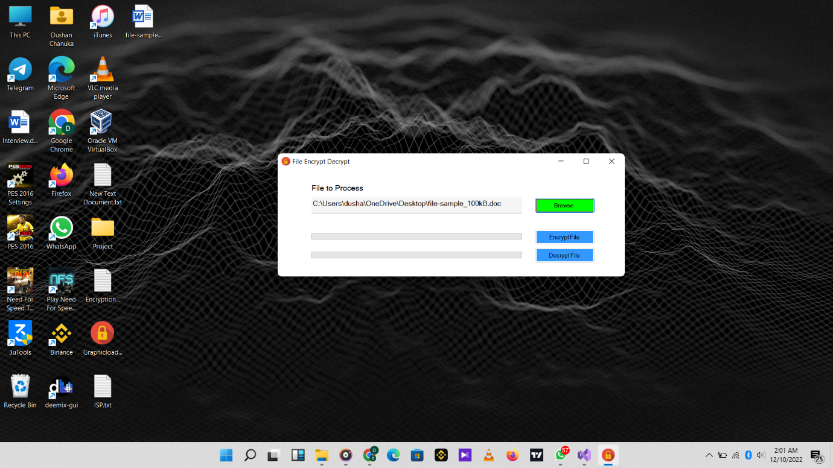

After that we need to hit the encrypt file button. Then it shows like this. The progress bar is filling while the encryption is going. As you can see that word file is converted into a unreadable file.

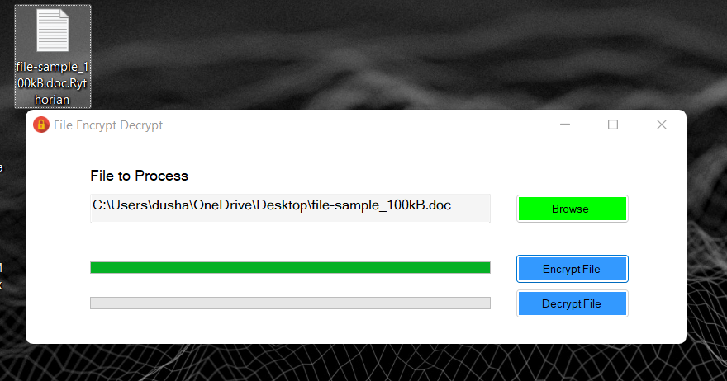

After the decryption process it shows unreadable characters like this.

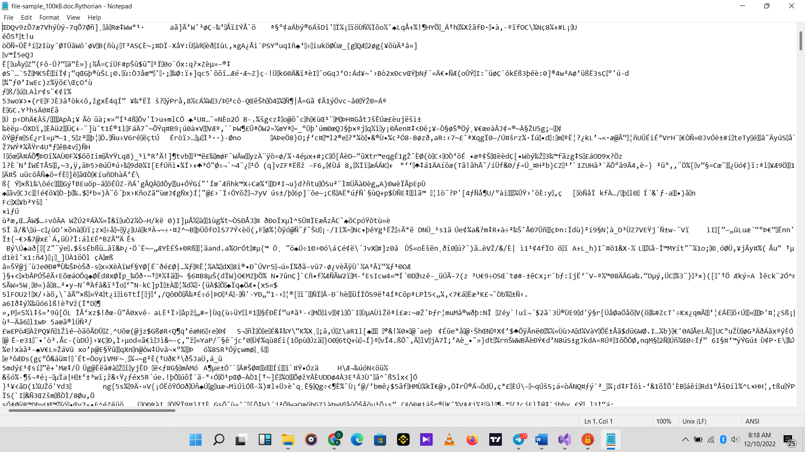

So after the encryption we want to decrypt the file again. In order to do that we need to browse again that unreadable file.

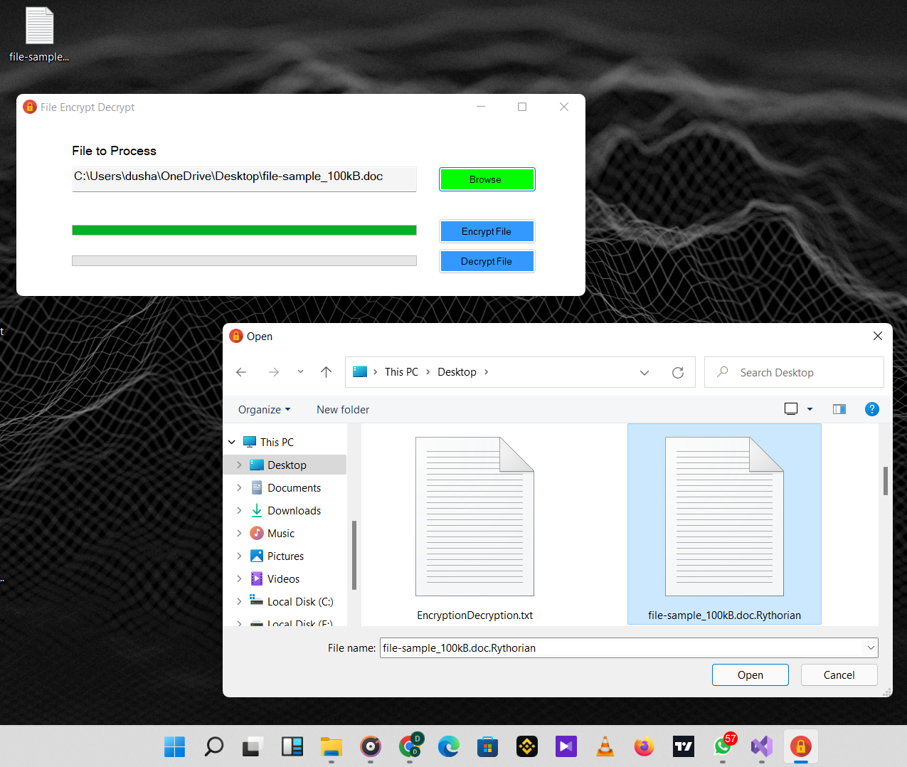

After we browse the unreadable file, its name and file directory shows in the text box. Then what we have to do is hit the decrypt button to decrypt it. After we hit the decrypt button, as we can see that unreadable file convert into a word document again. Now we can read the dox file as before.

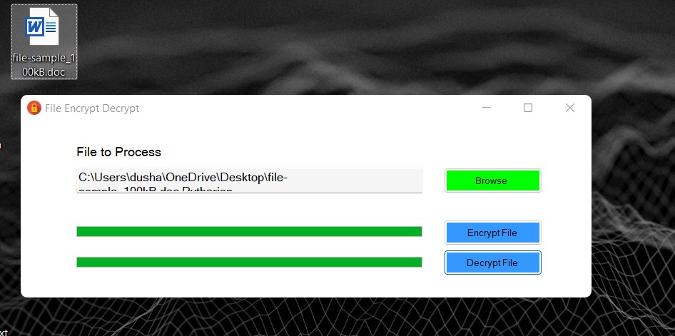

**Antivirus scanner**

An antivirus scanner is a component of antivirus software that scans a hard drive for viruses and other harmful items. These programs are designed for different operating systems and scanning methods can be manual or automatic. The scanner works in cooperation with other antivirus software components, such as virus containers and other tools.

Virus scanner is another name for antivirus scanner.

Although many software products now have a Windows-style or coded interface, most antivirus scanners still have a command-line interface. Most anti-virus scanners allow you to scan individual files on a drive to isolate viruses and remove them. As it scans the drive, the scanner usually displays its actions in a display window in a command-line structure.

Anti-virus scanners rely on a virus database, which must be updated regularly. Antivirus software manufacturers incorporate new virus and malware programs into their scanners and programs as they are developed. Anti-virus scanners are less effective and less likely to successfully quarantine viruses on a drive if the database is not kept up to date.

But in our case is not that complex antivirus scanner. It just a basic virus scanner. Let’s see what it is.

Code

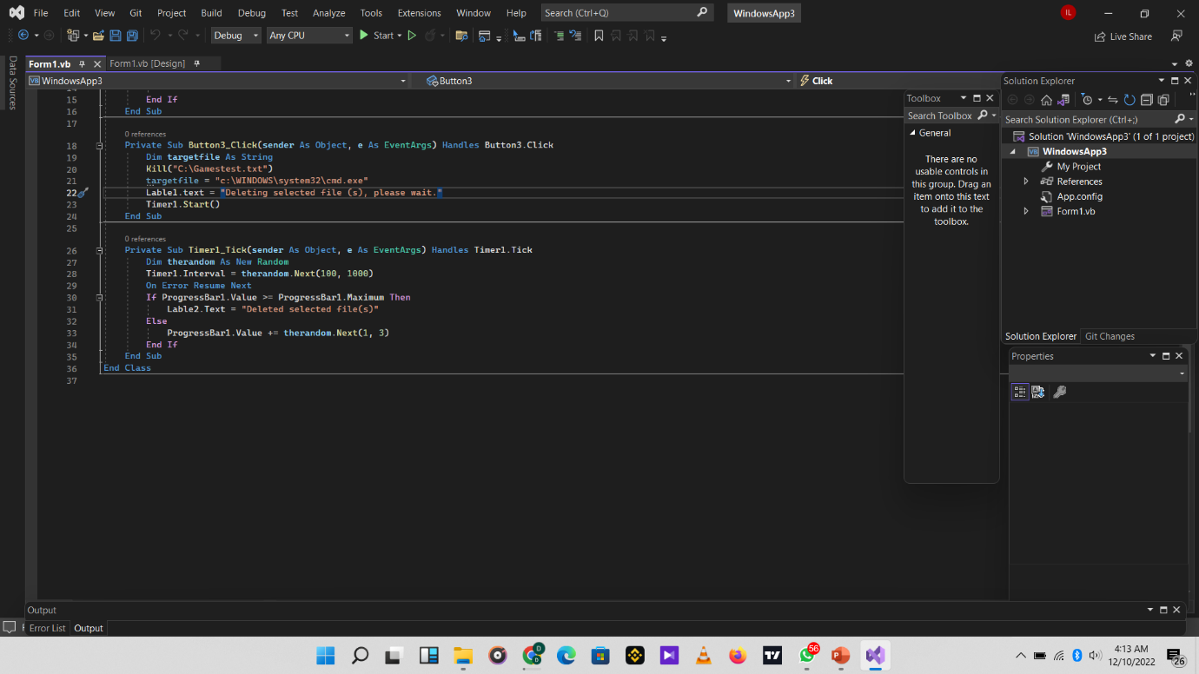

Interface

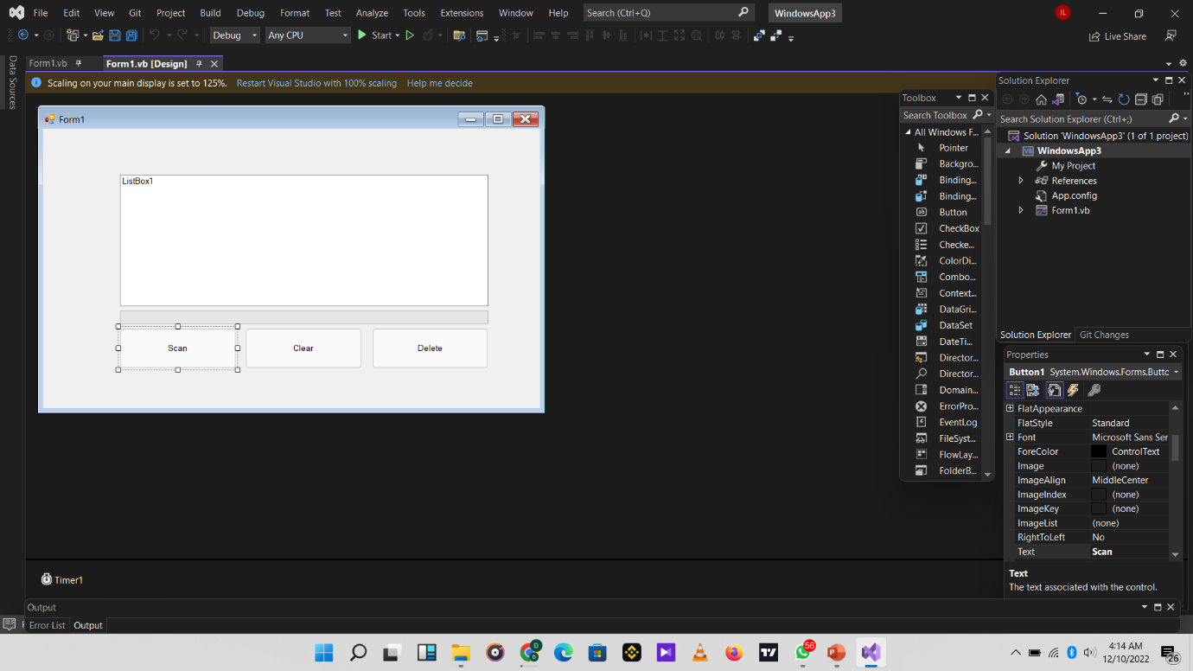

After we run our program, it shows like this. And then we have to hit the scan button to searching some malicious file in the pc.

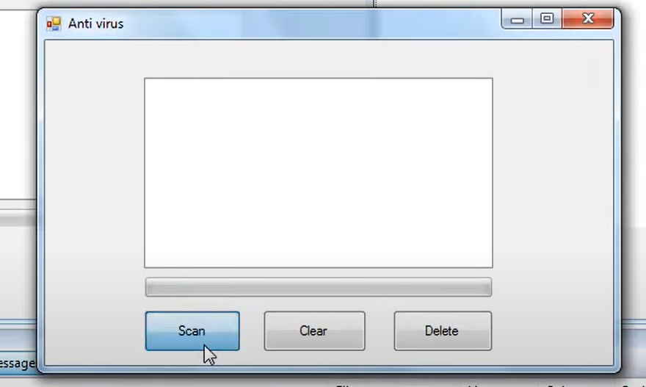

In our case we created a malicious file called BSOD.Activator. So after the scanning the tool shows that file as a malicious file.

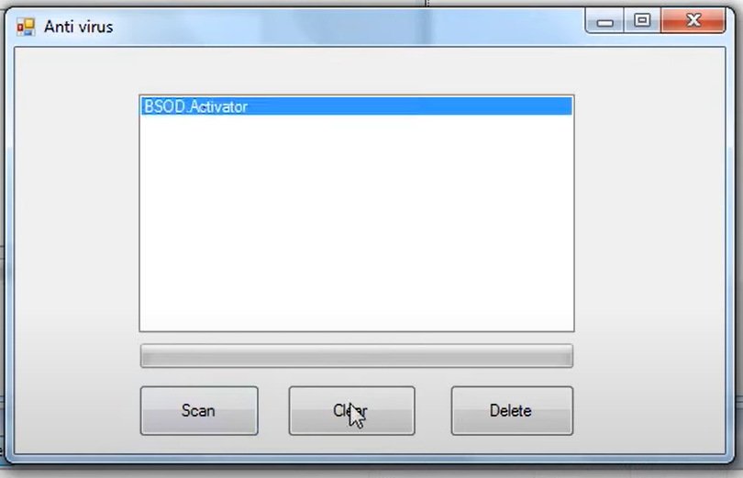

In order to delete that malicious file, we need to hit the delete button and wait for some seconds. And then it will be deleted.

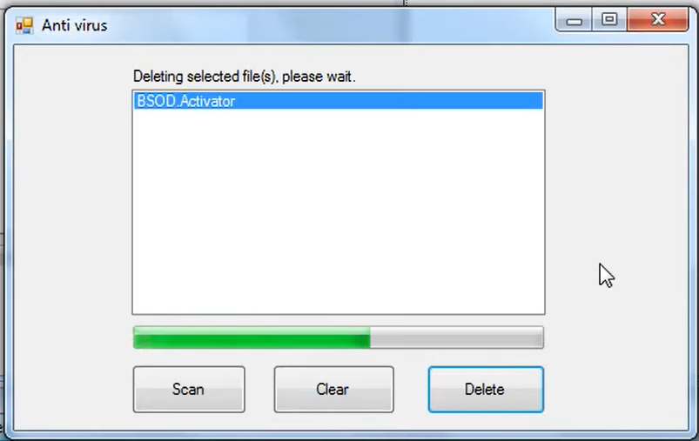

FACE RECOGNITION FOR LOGIN PAGE

Face recognition for the login page is one of modern security in nowadays information technology. A method of recognizing or verifying a person's identification using their face is facial recognition. People can be recognized using facial recognition technology in real-time or in still images and videos.

A subcategory of biometric security is facial recognition. Voice, fingerprint, and eye retina or iris recognition are examples of further biometric software types. Although there is growing interest in using the technology in other areas, security and law enforcement still account for the majority of its uses.

FaceID, which is used to unlock iPhones, has made face recognition technology widely known. Face recognition often does not rely on a huge database of images to identify a person; instead, it merely detects one person as the single the device's owner and identifies them as such, limiting access for others.

Facial recognition technology matches faces of persons passing by special cameras to pictures of people on a watch list, going beyond simply unlocking phones. The images on the watch lists can come from anywhere, including our social media accounts, and they can show anyone, even those who are not convicted of any crime.

**FUNCTIONS OF ROOTSEC**

***LOADING SPLASH…***

The splash screen was formed out of a requirement for apps to spend a few seconds setting up before the user can get moving. No matter how quickly your app launches, a few quick activities are almost always required by the operating system or your app code before the user can begin pressing buttons and browsing screens.

Your app might need to load some fundamental information so that the user can see content on the initial screen. If your user hasn't used the app recently, it's possible that they need to be authenticated again. Before that initial screen shows, it might be necessary to load a few important photos from the server.

Since operating systems have improved and apps can now launch almost instantly, there is much discussion today about whether or not a splash screen is still necessary. However, splash screens are still present in almost all major apps and provide a great opportunity for us to prepare before the main screen is displayed.

The 3-second rule

Before analyzing how to create this screen as good as it can possibly be, we should take a look at some restrictions. The splash screen would load quickly, to start. How soon? As soon as you can, but never for more than two or three seconds. Any user who regularly uses your app will become irritated if they must wait for it to open for even more than a few moments. Furthermore, why would you choose to keep them outside when you could have them inside clicking buttons, purchasing goods, and interacting with others? So whatever your splash screen plan is, make sure that if it crosses the 3-second guideline, you come up with a new method.

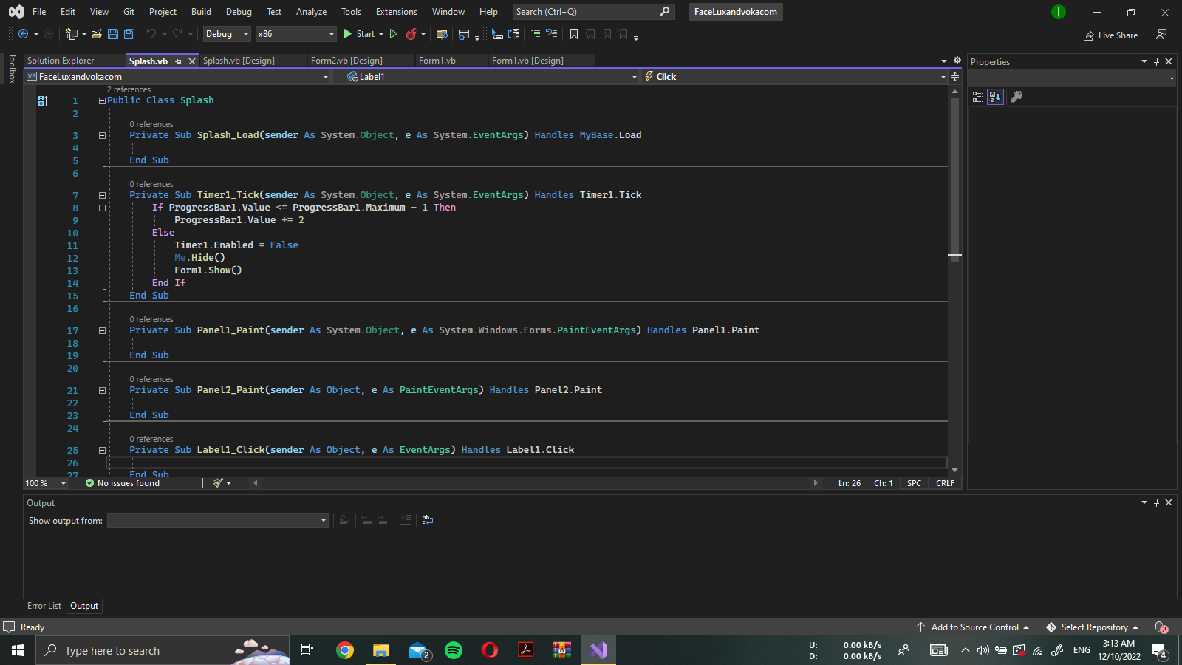

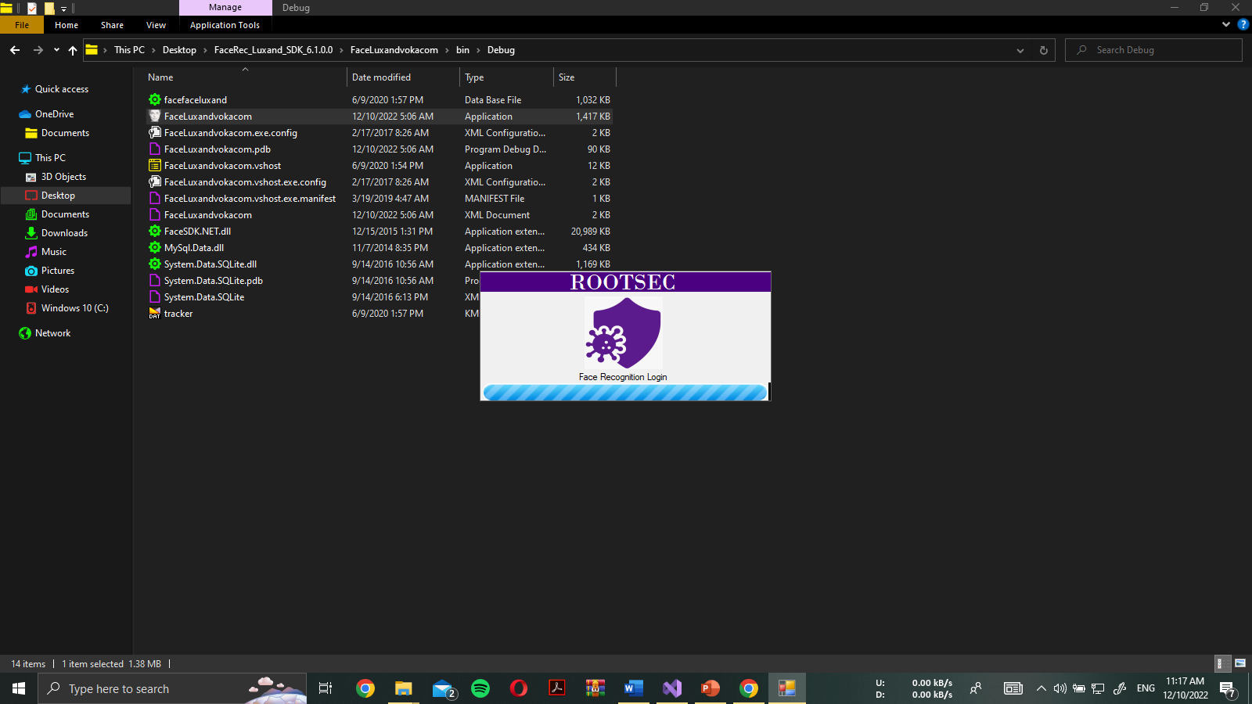

***LOGIN INTERFACE…***

The login page is a staple of all secure applications and is frequently used online to verify user identity before displaying the secured sections of web apps. As an illustration, Facebook requires authentication before granting you access to their platform. A unique website page called Login Page is used for user authentication. You must first input your credentials into the Login screen, which the application will validate before presenting you with the secured portion of the application.

In this illustration, we'll see how a login page is actually used in a web application or other kind of application. For instance, you must provide your username and password to log into the system if you must use the Windows or Linux OS. In order to determine if you are an OS authorized user or not, the login page will verify your identity. If it is not, you will be unable to the OS and can't even access it. A very old procedure that has been in use since operating systems were created is the security and identification of any program. Linux is regarded as the most secure operating system and does a great job at managing security.

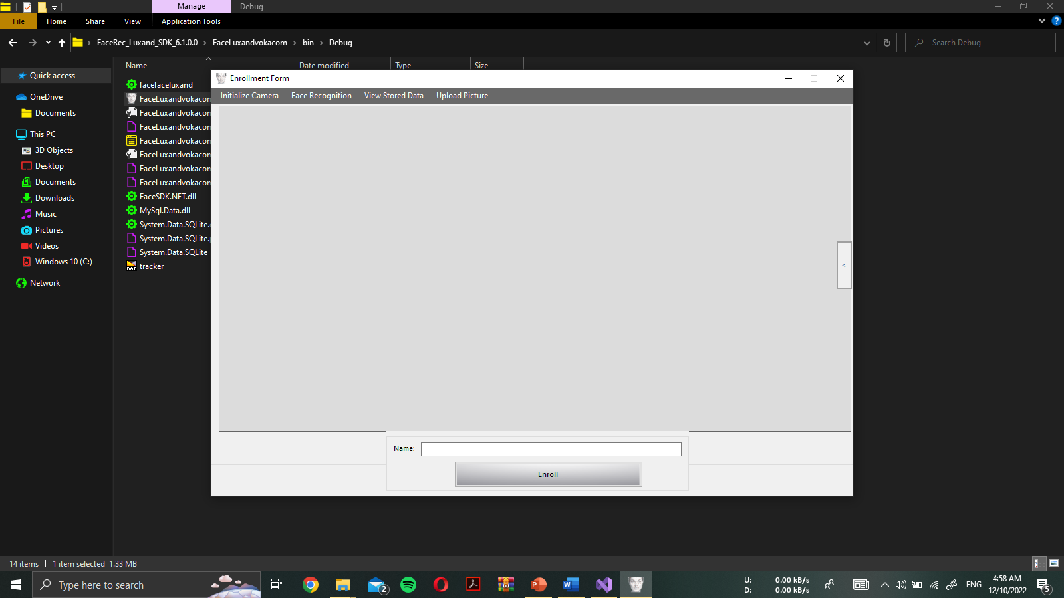

In this authentication process, the first step is to initialize the camera. Simply permit the application to locate the camera and operate in control here. After setting up the camera, you may access the facial recognition tab. If you're visiting this application for the first time, you must enroll there. If you're already logged in to the application, you can just go to the login process otherwise. Additionally, if you are a legitimate user, there is another option called view saved data that provides access to your stored data. Additionally, the image can be uploaded as your profile photo. That is a recent addition to my feature set.

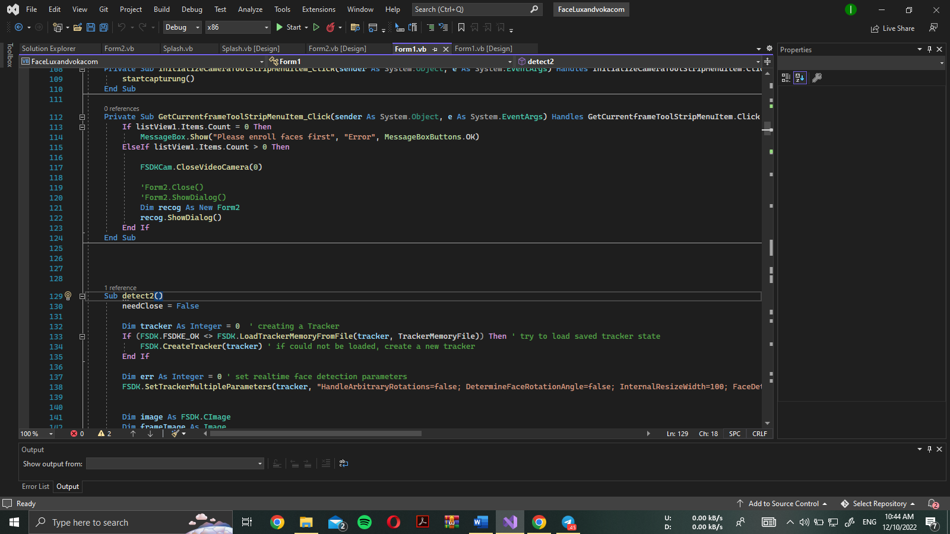

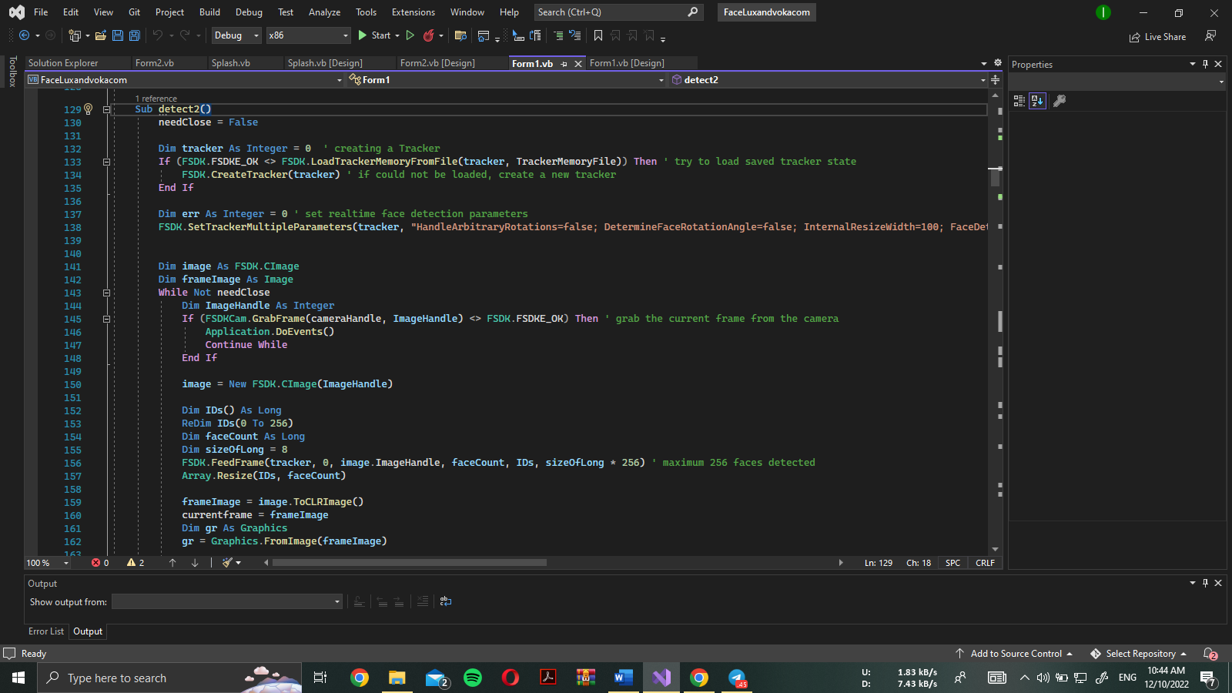

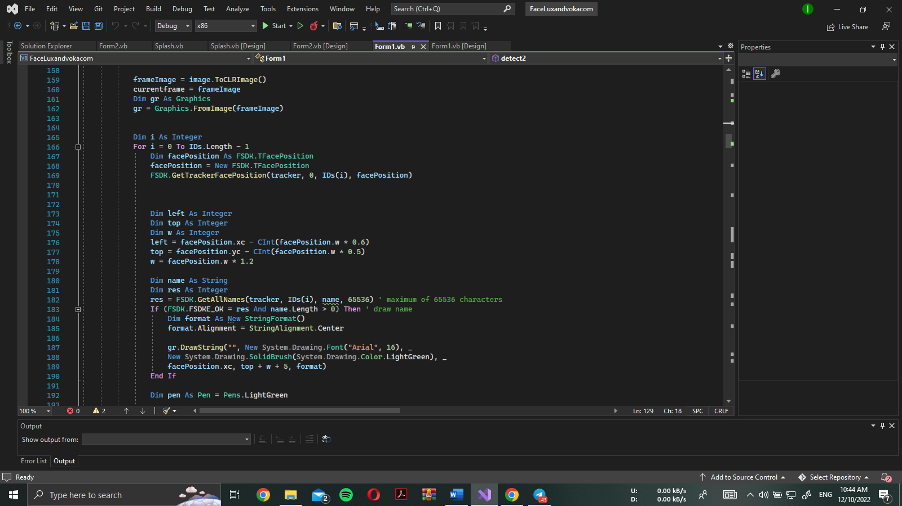

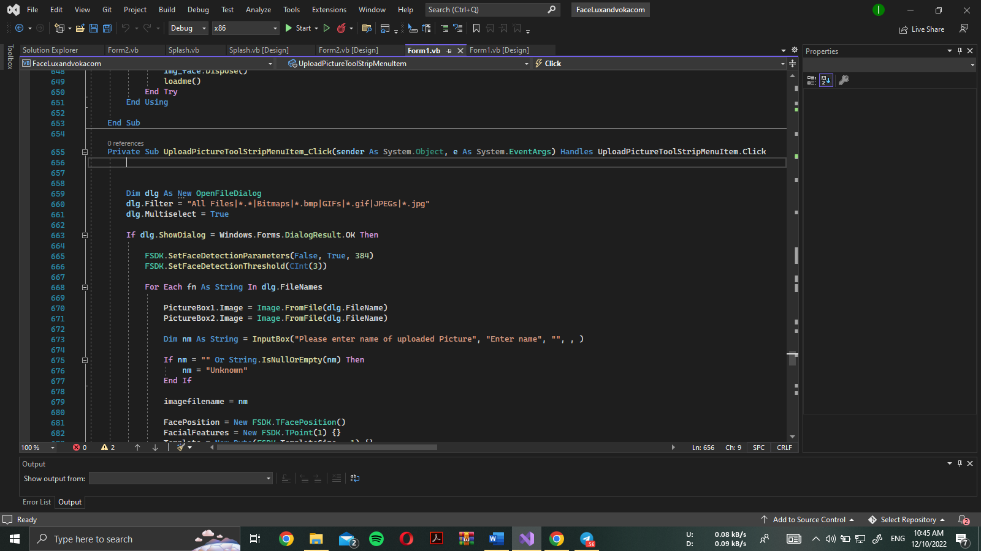

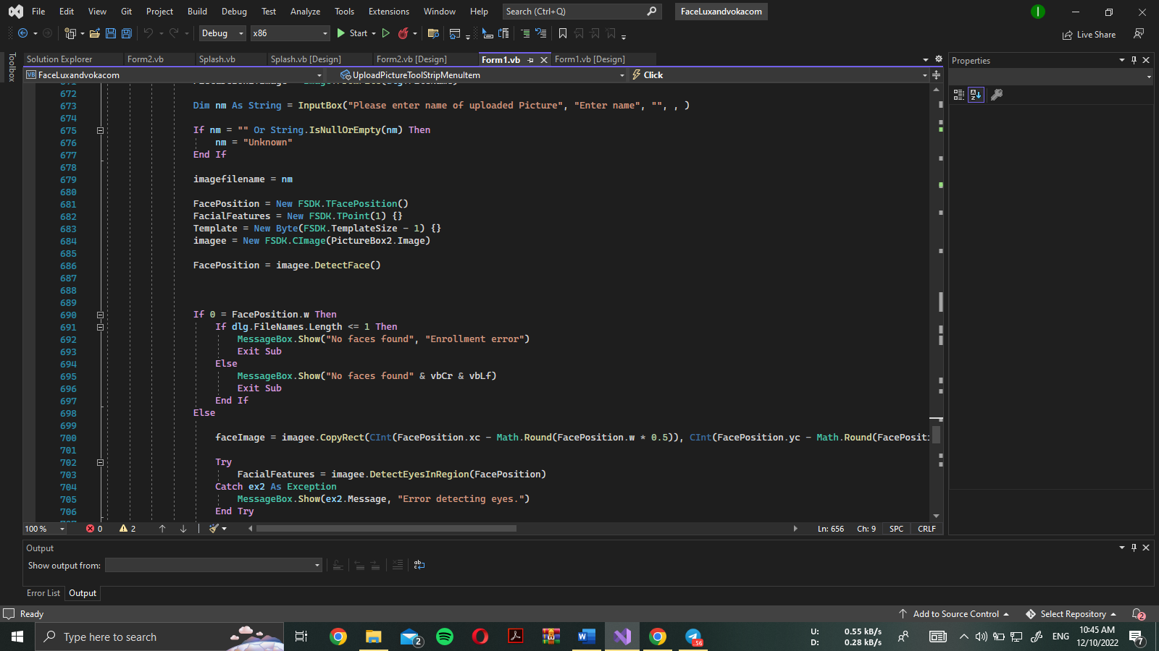

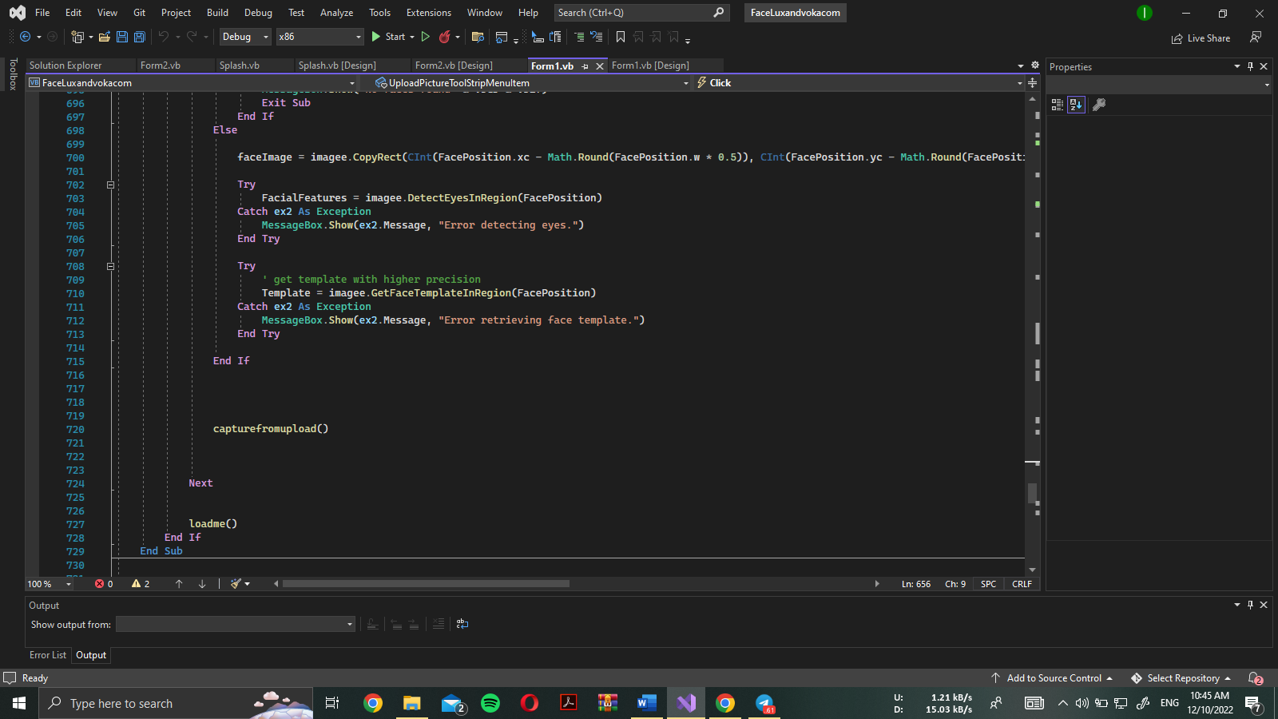

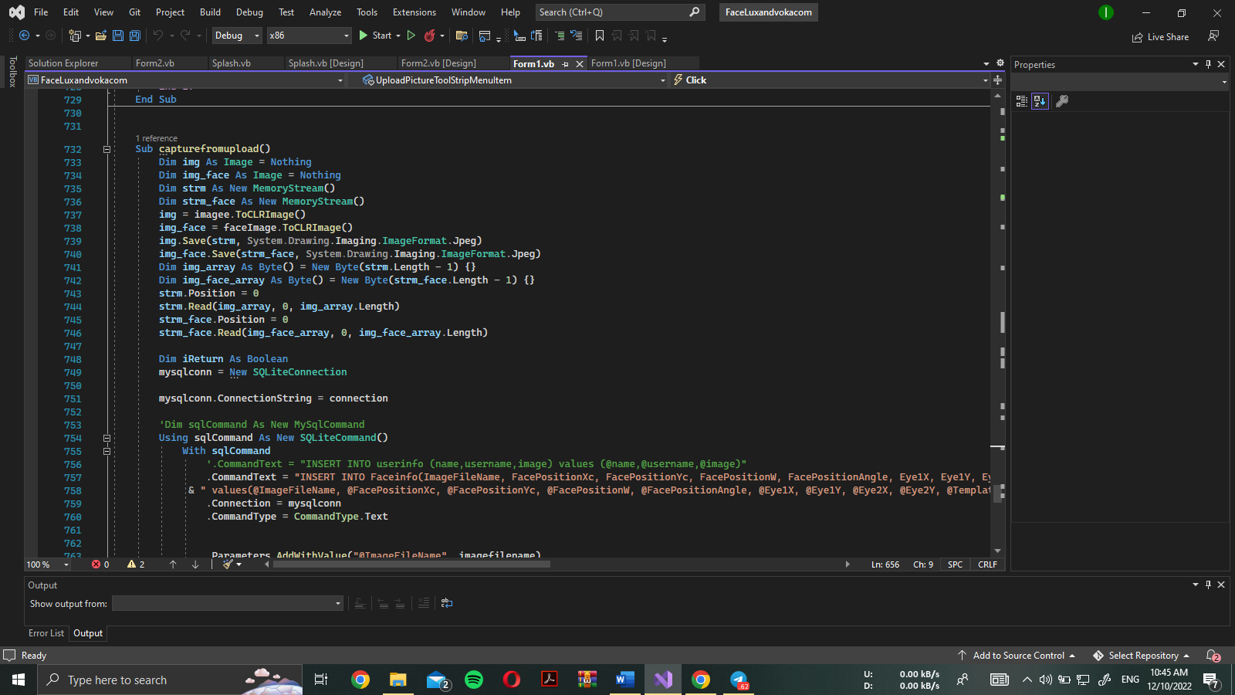

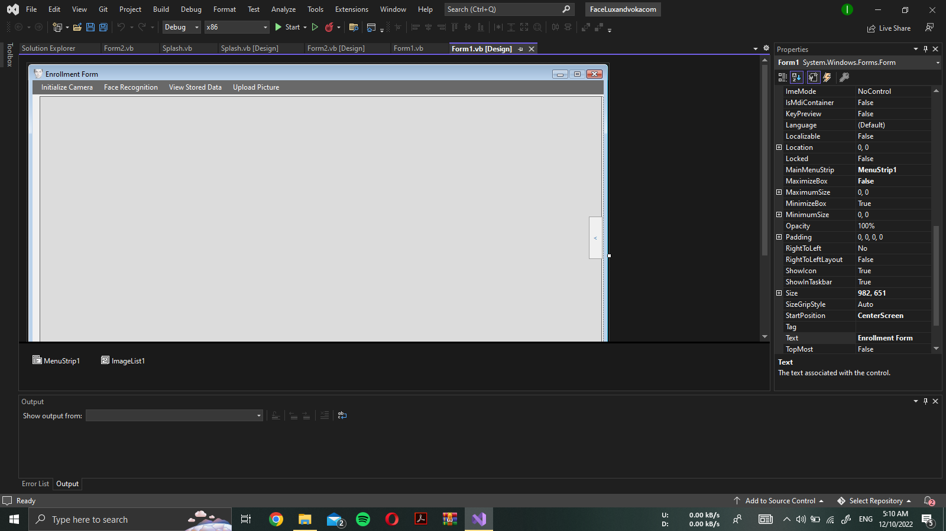

***Enroll the new user***

If you a new user who wants to try our application, you can simply go through the authentication process. And you give the name and hit the enroll button, camera will be started automatically and tying to take a snapshot of your face. Once the authentication process is done, you can go through.

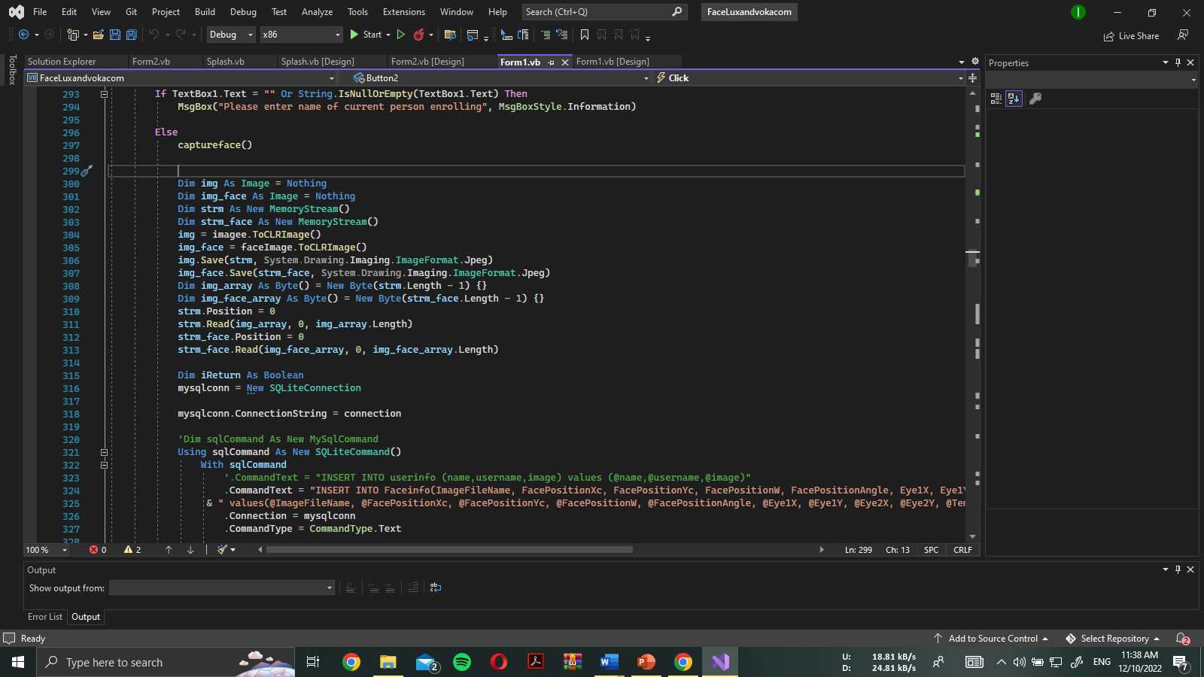

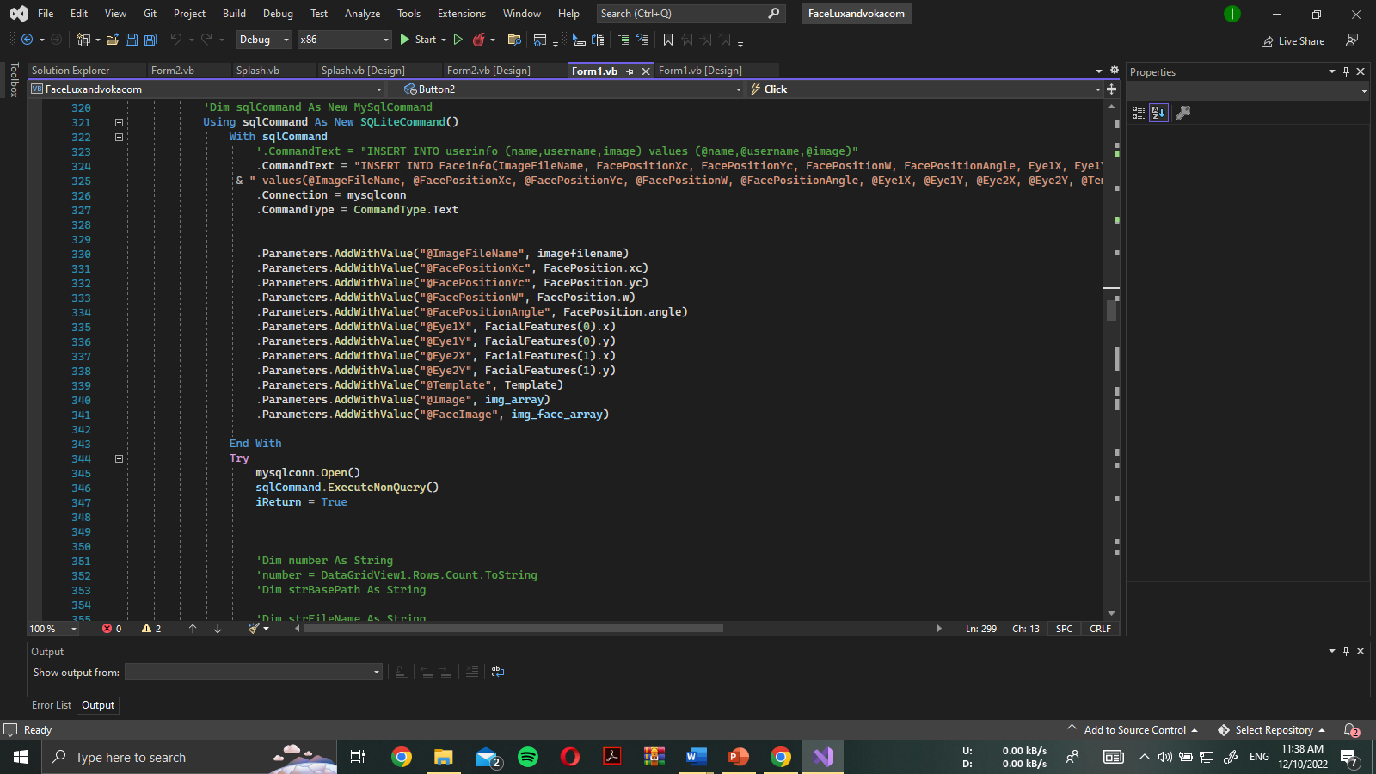

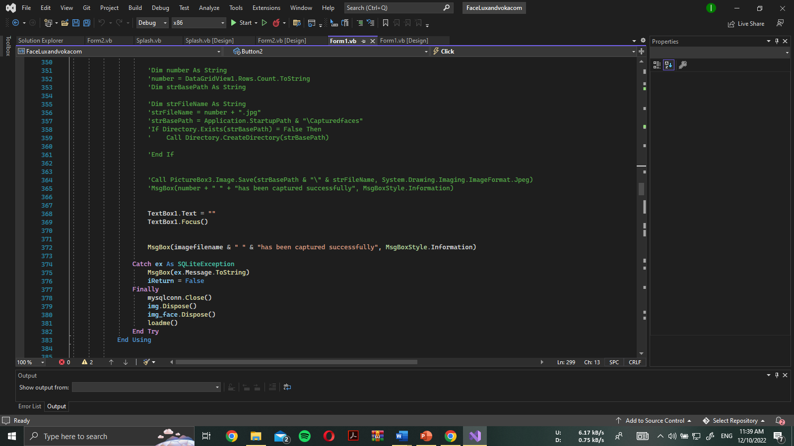

Implementation will be:

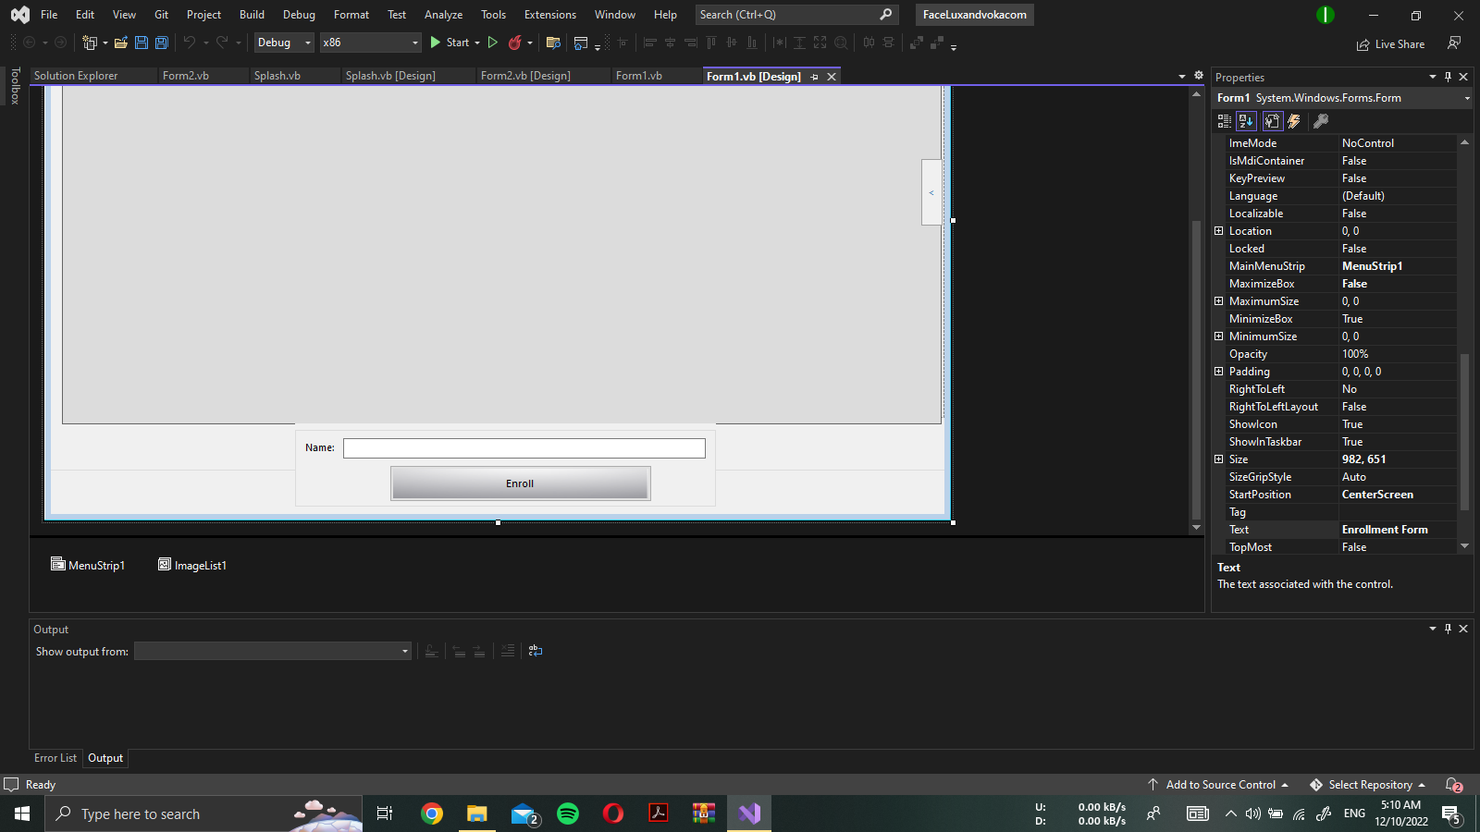

***Login of authenticated user***

User authentication authorizes a human-to-machine transfer of credentials during network interactions to verify a user's authenticity. This process checks the identification of a user trying to access a network or computational resource. Machine authentication, an automated authentication technique that doesn't require user input, is in contrast to the word.

By preventing unauthorized users from entering a system and possibly causing damage, stealing data, or other issues, authentication helps ensure that only authorized users can access a system. With the exception of guest and automatically logged-in accounts, almost all interactions between people and computers include user authentication. In order to grant access to networked and internet-connected devices and resources, it authorizes access on both wired and wireless networks.

